# IT 230 Coding Activity Submission Template

Submit your work on the coding activities for Modules One, Two, Three, Four, and Six in this document. In addition to this document, you should submit a ZIP file containing all your Visual Studio project files and source code that can be run in Visual Studio on a different computer.

For each coding activity, complete the following steps:

* Download and rename this document to meet the file naming conventions requested in the assignment instructions.
* Fill in the required information below by replacing the bracketed text with the relevant information.
* Submit this document and your ZIP file for grading and feedback. Your ZIP file should follow the same naming conventions.

Document your work in the coding activity by completing each of the following items:

1. Provide a screenshot of the output that resulted from running your program successfully in Visual Studio. See the coding assignment instructions for an example of what should be included in the screenshot. Your screenshot must include the following elements:
   1. Your last name as the first printed text on the screen
   2. Verification that the program is fully functioning and data results are accurate for the given problem

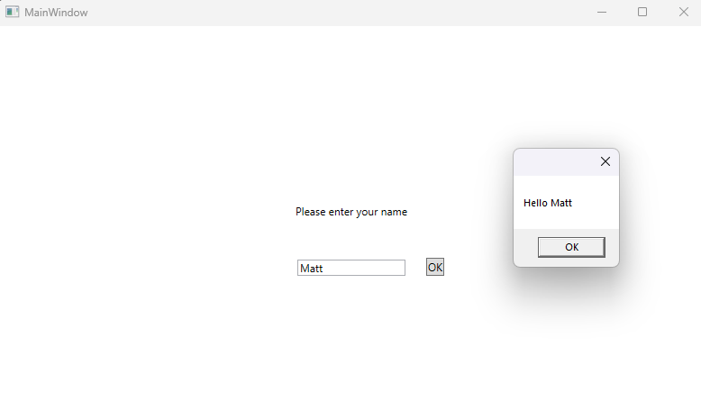

1. Copy and paste the source code text you wrote for this assignment from the *.cs file into the space below. Only providing the *.cs files or a screenshot does not meet the requirements for this part of the assignment. Code should be logically organized. It should also follow proper syntax and conventions noted in the Coding Activity Guidelines and Rubric.

using System.Text;

using System.Windows;

using System.Windows.Controls;

using System.Windows.Data;

using System.Windows.Documents;

using System.Windows.Input;

using System.Windows.Media;

using System.Windows.Media.Imaging;

using System.Windows.Navigation;

using System.Windows.Shapes;

namespace HelloMatt;

/// <summary>

/// Interaction logic for MainWindow.xaml

/// </summary>

public partial class MainWindow : Window

{

public MainWindow()

{

InitializeComponent();

}

private void TextBox_TextChanged(object sender, TextChangedEventArgs e)

{

}

private void okClick(object sender, RoutedEventArgs e)

{

MessageBox.Show($"Hello {userName.Text}");

}

}

1. Show that you understand the task by explaining the design of your program in the space below. Include the process and steps you took to write your code. Explain how you arrived at the solution to the problem and completed the activity.

Frankly, the only step I took was that which was explained by the project. I created the template utilizing the built-in tools of the IDE and the instructions of the project, then dragged in a text block, text box, and a button. The text block is simply there to display instructions. The user can fill in a name to the text box, which becomes a variable, which is then output to the message box as “Hello {variable}” when the button is pressed.

1. Reflect on your learning experience and what you learned from completing the activity.

I thought this simple project was cool, and that it was a good learning experience for the IDE and C#. Being able to create an application with buttons and a layout so simply is powerful and exactly what I’ve been wanting with regards to application development.